**Mystifier**

**Architecture Solution**

**Question #1: *Do you agree with Mystifier to store external system data of users on their servers? Please answer with reasoning.***

***Answer:*** *It all depends on the business needs. I would agree with the CTO’s decision to store the data to the external system based on the following points:*

1. *Data can be processed to extract information that can be useful for Mystifier.*
2. *They can use that data to help other businesses.*
3. *They can provide their users with different filtration options for reports.*
4. *Every social networking API comes up with a rate limit. It can be consumed to its limit if we query API every time the user asks for report.*
5. *It could delay the response if we had to generate the report through API every time.*

***Question2#: What would be application architecture?***

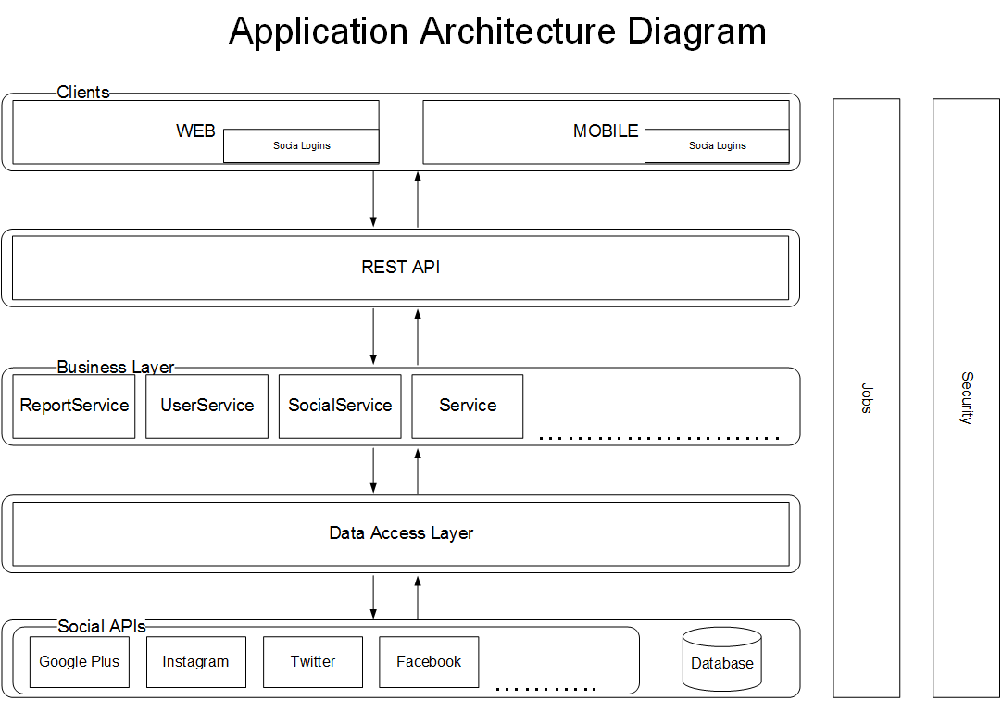

***Question3#: Please create ERD with current information in hand.***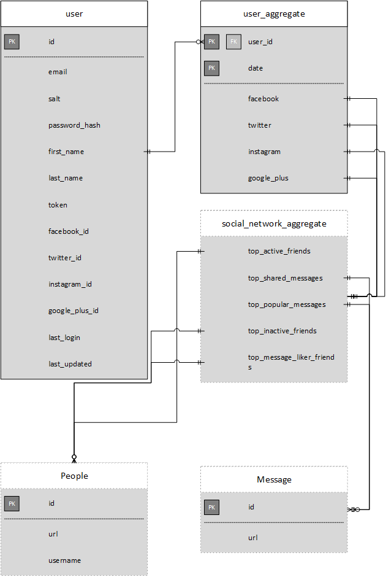

***Question4#: Please draw deployment diagram of above proposed solution.***

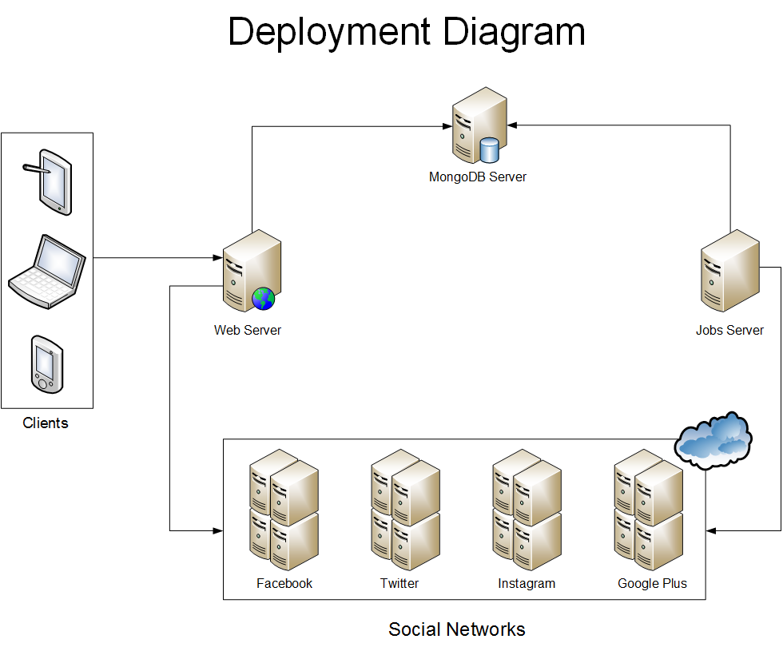

***Question5#: Which technologies you will propose to build above solution (Programming language, database etc)?***

***Answer:***

**Backend:** Nodejs  
**Frontend:** Angularjs

**Database:** NoSQL(MongoDB)

***Question6#: Mystifier has done marketing push now they are expecting X number of users do you think proposed architecture will support X number of users and can be scaled up with company growing needs, if not then what changes are required to make solution scalable?***

***Answer:***To make the solution scalable we can make following few changes: